

Transport For London

Document Bundler Loader Data Cleansing
Extensions to the Exor Document Bundler Loader

Version 01.0

Document Version History
Version | Update Source | Date | Description
00.01 | Harry Bbuckley | 08th July 2013 | Initial Draft
For review |  |  | For approval
Zubran Solaiman (Bentley)

Table of Contents
1 Introduction 4
1.1 Purpose 4
1.2 Related Documents 5
1.3 Related Documents 5
1.4 Software Installation ……………………………………………………….……..6
1.5 Process Type Definition ……………………………………..…………………. 6
1.6 Process Execution …………………………………………………………….7

Introduction
This document describes the extensions to the Exor Document Bundler Loaded data cleansing routine that has been specifically developed to remove data which is deemed to be ‘date expired’ from the system.

The software provided should be relatively easy to install and should perfom the
Required tasks.

Purpose

A database package has been produced to perform deletions from specifc tables, the
Package will be executed via a defined system process which will also be made availablel by the installation of this piece of software.

The software should be installed against a v 4500 system and above.

The following abbreviations, terms and concepts are used in the document:

Related Documents

None.

Unpacking the software

The software will be supplied either as part pof a wider product or will be supplied as an independent zip file.

In the case of the zip file a user should be able to unzip the contents of the file to a local directory of an application server and using SQL*Plus it should be possible to install the software into the system via the HIGHWAYS OWNER schema.

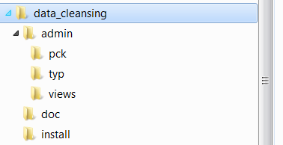

The above details the directory structure for the installed software.

Software Installation

The installation of the software requires the execution of a SQL script.
Within the ‘install’ directory there is a file named insp.sql and this should be called from within a SQL*Plus session ( see below ).

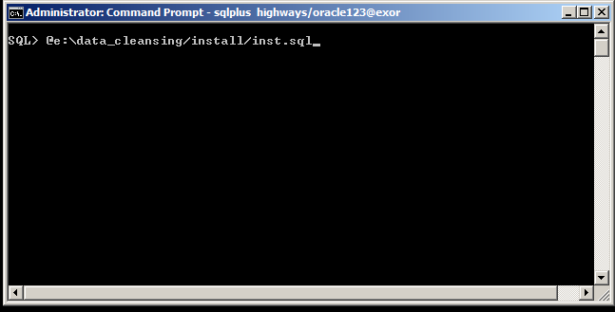

Upon entry , the software should be installed and a log file produced. The name of the log file will be data_cleansing_1_<date/time>.log

Please check the log file upon completion.

Process Type Definition

Once installed , the following process type should be available for use.

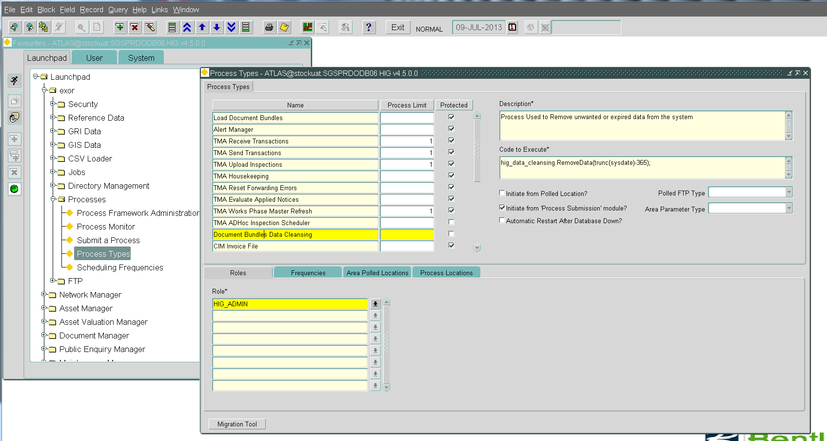

The important part of this configuration is the ‘Code to Execute’ section on the right hand side of the HIG2500 ( Process Types ) form.

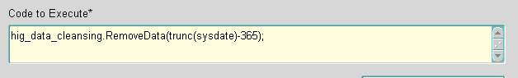

This section executes the database package with a parameter of :

Trunk(sysdate)-365

The trunk function removes the time element from the date and the -365 ensures that data is only removed where the data is greater than 1 year old.

Note: If there is a large amount of data in the system ( say many years of data ) then the 365 value may need to be increased. We may need to do this because there may be too much date to be removed for the rollback segments and this could lead to a breakdown of the database.
It may also be an idea to disable Archive Logging while the deletion process is executing , first having backed up the database just in case there are any unforeseen issues.

If necessary a query could be provided which would provide information on the Number of Rows in the selected tables BY YEAR.

Process Execution
A process can be executed either as a one-off execution or it can be scheduled to be executed for a specified frequence with or without user intervention.

Out of the box, the process defined has been provided with a frequency of ‘Once’ and as such should be executed manually from the HIG2510 Submit a Process form

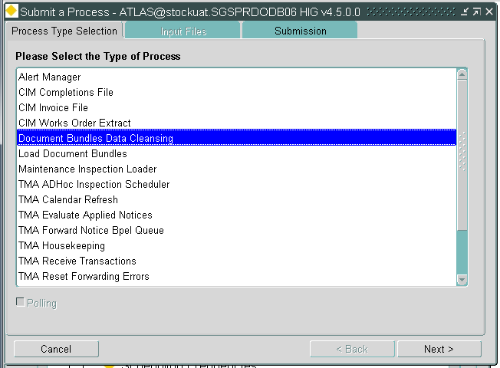

The process should be executed in the standard manner and the HIG2520 Process Monitor form should be used to monior the execution of the process.

